CPU: Intel i7-7700k 4.20GHz current utilization 3%

Robert’s PC
RAM: 32 GB current utilization 22%
Storage: 233 GB SSD free space 46 GB
GPU: Dedicated
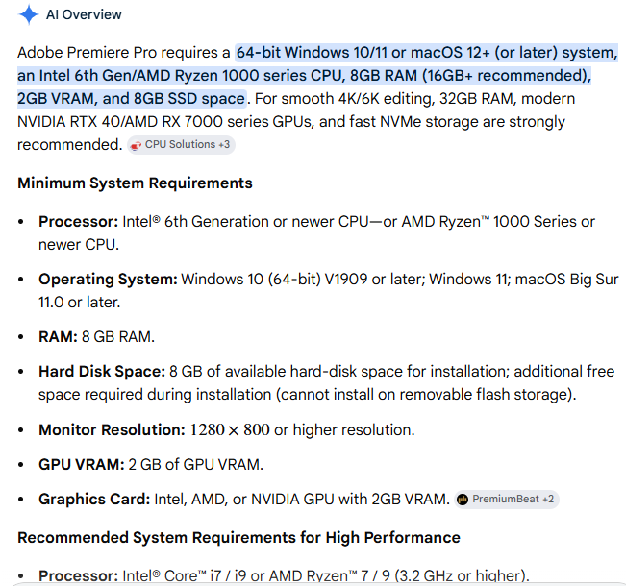

Component | My System Spec’s | Adobe Requirement | Spec’s Compatible
RAM | 32GB | 8GB | Yes
CPU | I7-7700k | 6th Gen | Yes
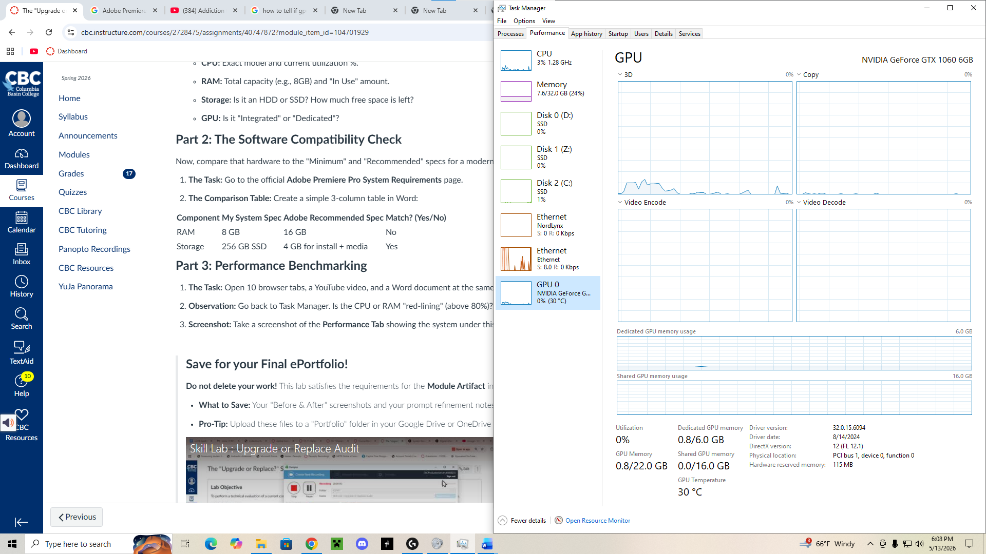
Nothing really changed under the “load” I think it might if I actually run 10 videos on my tabs at the same time though. The computer is a master of multitasking.

